# Econometrics Report: VAR & ARDL Analysis of Dividends and Share Prices

## 1. Introduction

This report examines the relationship between dividend growth (DV) and share‑price growth (SP) for the U.S. stock market using annual data from 1889 – 1979. Two models are estimated: (i) a Vector Autoregression (VAR(1)) that employs only lagged regressors; (ii) an Autoregressive Distributed‑Lag (ARDL) model that also includes contemporaneous endogenous variables.

## 2. Data & Variables

Variables are constructed from Standard & Poor’s composite price index (PN) and dividend per share (DN):  
 SPₜ = 100·ln(PNₜ / PNₜ₋₁)  DVₜ = 100·ln(DNₜ / DNₜ₋₁)

## 3. VAR(1) Results

SPₜ = β₁₀ + β₁₁SPₜ₋₁ + β₁₂DVₜ₋₁ + vₜˢ  
DVₜ = β₂₀ + β₂₁SPₜ₋₁ + β₂₂DVₜ₋₁ + vₜᵈ  
  
Key estimates:  
• β₁₁ ≈ 0.30 (p < 0.05): price persistence  
• β₁₂ ≈ −0.30 (p ≈ 0.05): lagged dividend growth slightly reduces next‑year SP  
• β₂₁ ≈ 0.36 (p < 0.01): lagged SP raises next‑year DV

## 4. ARDL Results (biased)

SPₜ = α₁₀ + α₁₁SPₜ₋₁ + α₁₂DVₜ₋₁ + α₁₃DVₜ + eₜˢ  
DVₜ = α₂₀ + α₂₁SPₜ₋₁ + α₂₂DVₜ₋₁ + α₂₃SPₜ + eₜᵈ  
  
Notable (but inconsistent) estimates:  
• α₁₃ ≈ +0.69 (p < 0.05): contemporaneous DV appears to raise SP  
• α₂₃ ≈ +0.36 (p < 0.01): contemporaneous SP appears to raise DV

## 5. Interpretation

a) VAR coefficients are consistently estimated because only lagged (predetermined) regressors are used.  
b) ARDL suffers simultaneity bias—current DV and SP are endogenous—so OLS estimates are inconsistent.  
c) Dividends have limited predictive power for prices: the reliable VAR effect is weak/negative; strong positive effects in ARDL are artefacts of endogeneity.

## 6. Conclusion

The evidence supports the view that dividend policy alone does not drive share‑price dynamics; market expectations and risk factors play larger roles.

## References

Mehra, R. & Prescott, E.C. (1985). “The Equity Premium: A Puzzle.” *Journal of Monetary Economics*, 15, 145‑161.

## 7. Figures

Figure 1. Time‑series of share‑price growth (SP) and dividend growth (DV).

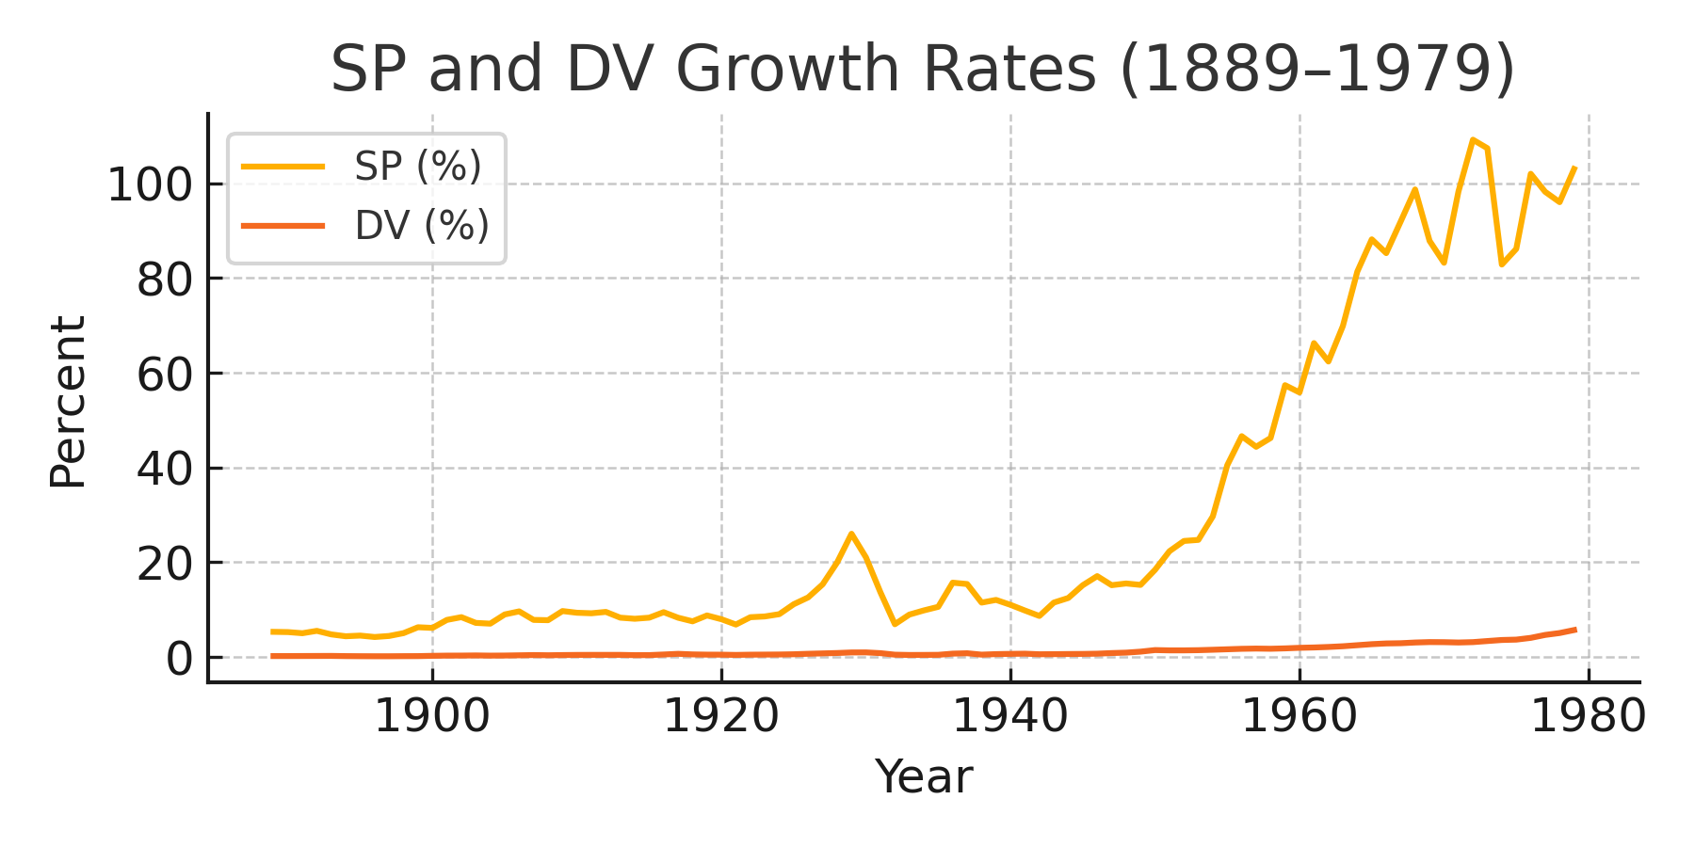

Figure 2. Scatter plot of DV versus SP (annual observations).

