Chapter 03 Exercises

Student ID: 11204604 Name: Tse Wen Hong

1. Stock prices for AllElectronics and HighTech

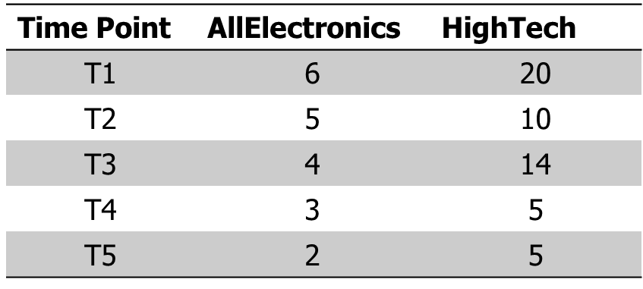

1. If the stocks are affected by the same industry trends, will their prices rise or fall together? **[ Yes]**
2. Pearson correlation = ? **[ 0.867 ]**
3. Suppose a group of 12 sales price records has been sorted as follows:

**5, 10, 11, 13, 15, 35, 50, 55, 72, 92, 204, 215.**

Partition them into three bins by each of the following methods.

(a) equal-frequency (equal-depth) partitioning

**bin1：5、10、11、13**

**bin2：15、35、50、55**

**bin3：72、92、204、215**

(b) equal-width partitioning

bi**n1：5、10、11、13、15、35、50、55、72**

**bin2：92**

**bin3：204、215**

(c) min-max normalization by setting min=0 and max=1

**bin1：5、10、11、13、15、35、50、55、72**

**bin2：92**

**bin3：204、215**

**[**[**Calculation**](https://docs.google.com/spreadsheets/d/1i-tCQv1EZ0qhRZxBnBc8ME5Hk5CygL0YzlFgtJ4NsPM/edit?usp=sharing)**]**